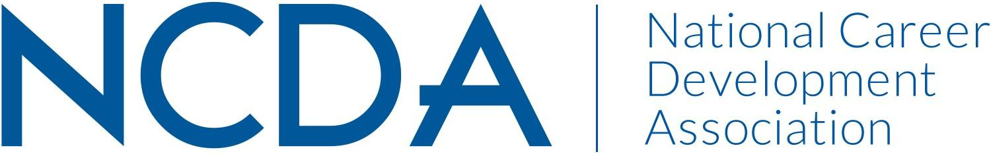

NCDA COMMITTEE MID YEAR REPORT

GRADUATE STUDENT COMMITEE
03/31/2025

Chair - Dr. Ramon Moon - ramon.moon@lindsey.edu
Co-Chair - Delasia Rice - delasiarice342@gmail.com

Committee/Council Activities to Date

Cultivating Community
- Reaching out to members who provided contact information at the last conference to gauge interest and strengthen leadership.
- Developing a stronger communication base to share membership benefits, increase exposure to other committees within the NCA, and encourage cross-committee membership within the NCDA. This will help expand and share ideas across different domains for a more well-rounded committee.
- Implementing monthly coffee chats and developing a bi-monthly or quarterly newsletter featuring events at various universities and companies, aligning with the mission of the Graduate Student Committee and the NCDA.

Career Empowerment
- Reaching out to members who provided contact information at the last conference to gauge interest and strengthen leadership.
- Establishing a stronger communication framework to highlight membership benefits, increase visibility of other committees within the NCA, and promote cross-committee engagement within the NCDA. This initiative will foster idea-sharing across different domains, creating a more well-rounded committee.
- Introducing monthly coffee chats and developing a bi-monthly or quarterly newsletter featuring events at various universities and companies, aligning with the mission of the Graduate Student Committee and the NCDA.

Projected Plan/Work Planned to be Completed through September 30.

- Pair incoming graduate students with experienced peers for guidance and support
- Host sessions on stress management, mindfulness, and work-life balance - Virtually inviting other members from other committees to provide these sessions
- Host sessions on resume building, networking, and job market trends

