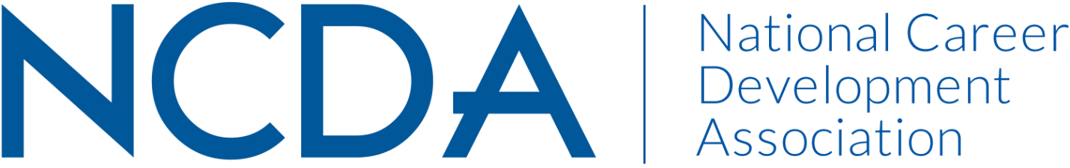

Annual/Mid-Year Report

GOVERNMENT RELATIONS (GR)
March 15, 2024

Leadership Information

- 2023-24 Co-Chair - Elle O’Flaherty, elleoflaherty@interlacesolutions.com; 202-906-0618; 1864 Monroe St., NW, Washington, DC 20010
- 2023-24 Co-Chair - Shelby McIntyre, smcintyre1@pasadena.edu; shelbynmc@gmail.com; 541-207-6506; 12817 Moorpark St. Apt. 4 Studio City, CA 91604
- List Committee Members - Natalie Kauffman, Sarah JanTausch, Amy Policastro, Lana Kaye Farley, Steve Myers, Jonae Watts, Rae Stout, Sherita Bryant, Patricia Ferguson, Maisie Lynch, Jill Minor, Margi Williams, Steven D. Thomas, Saecilia Jackson, Ann Dawson, Ron Cathey, Terence Chia, Diana Bailey, Rebecca Dedmond
- Board Liaison- Marty Apodaca
- Lobbyit representative(s)- Casin Spero; Jonathan "JT" Taylor

Activities to Date:
Strategic Planning
- Completed strategic planning process to identify workstreams and actions throughout 2023-2024. See GR Workstreams & GR Action Plan.
- Wrote NCDA Policy Areas platform and received committee and NCDA Board approval. This document establishes NCDA’s policy platform and areas of focus. See NCDA Policy Areas.
Policy
- Delivered on federal proclamation of November 2023 as National Career Development Month and proclamations in the following states: Maryland, New Hampshire, North Carolina, Ohio, Washington, DC, and Vermont.
  - Additionally, submitted proclamation requests in the following state: CA.
Member Services
- Continued relationship & collaboration with Lobbyit and the American Counseling Association (ACA). Provided breaking legislative updates to NCDA Members through weekly, monthly, and quarterly reports (while the congress is in session) from Lobbyit.
- Identified National Career Development Association (NCDA) members’ needs and priorities for legislative advocacy through the use of an association-wide survey.
- Analyzed and incorporated survey feedback into NCDA Policy Areas platform.
- Held 1st Quarterly State Contacts meeting, 13 people registered & 9 participated from states including CO, MD, MI, NC, OH, & VA.
Communication
- Updated NCDA GR Website with new information, including updated State Contacts page, NCDA Policy Areas platform, and updated policy reports.
- Contributed two articles to September 2023 Career Developments Magazine.
- Recorded an episode for NCDA Podcast 3/11/24 to be released 5/2024, informing NCDA members on committee happenings and advocacy strategies.
- Wrote public statements & received board approval:
  - NCDA GR Public Statement on Unpaid Internships
  - NCDA GR Endorsement Statement - CAREERS Act
- NCDA GR Committee voted to endorse the following legislation:
  - H.R. 6585: Bipartisan Workforce Pell Act
  - H.R. 7128: WOSB Integrity Act of 2024
  - H.R. 7105: WOSB Certification and Opportunity Expansion Act
  - H.R. 7102: Native American Entrepreneurial Opportunity Act
  - H.R. 3511: Service-Disable Veterans Opportunities in Small Business Act
  - H.R. 7395: Counseling for Career Choice Act (H.R. 2733 last Congress)
  - Reintroduction of the Skills Investment Act

Projected Plan through fiscal year end (September 30th)
- Hill Day scheduled for May 15-16, 2024.
  - Create half-day training for participants on advocacy 101 and best practices during Hill Day.
  - Set priorities for congressional and administration meetings.
  - Write leave-behind with information about NCDA and its policy positions.
- Hold additional Quarterly State Contacts meetings May 6, Aug 5, and Nov 4.
- Identify potential candidates for Legislative Award and submit the NCDA 2024 Legislative Award.
- NCDA Webinar “Advocacy in Action: How New Legislation Will Transform Career Development” scheduled for Tuesday, April 30, 2024 1:00 - 2:00 pm (Eastern Time).
- Contributions to NCDA 2024 Conference:
  - NCDA GR Committee Meeting Thursday, June 27 from 12:00 – 1:30 pm.
  - Government Relations National Committee Session [briefing on legislative updates from the 23-24 year as well as legislative priorities and proposed next steps for 24-25] Thursday, June 27 from 1:50 - 3:00 pm.
  - Creating Spaces for Advocacy with State CDAs hosted by NCDA GR member Sarah JanTausch Thursday, June 27 from 3:30-4:40 pm.
- Collaborative goals with LobbyIt:
  - Position NCDA as a subject-matter expert in the legislative and executive branch.
  - Amplify NCDA’s “brand” to increase its recognition among lawmakers and relevant stakeholders.
  - Forge new relationships and foster existing relationships in Congress and government agencies.
  - Proactively insert NCDA into relevant conversations surrounding its policy priorities.
  - Enact a plan for the prolonged Congressional recess in 2024.

