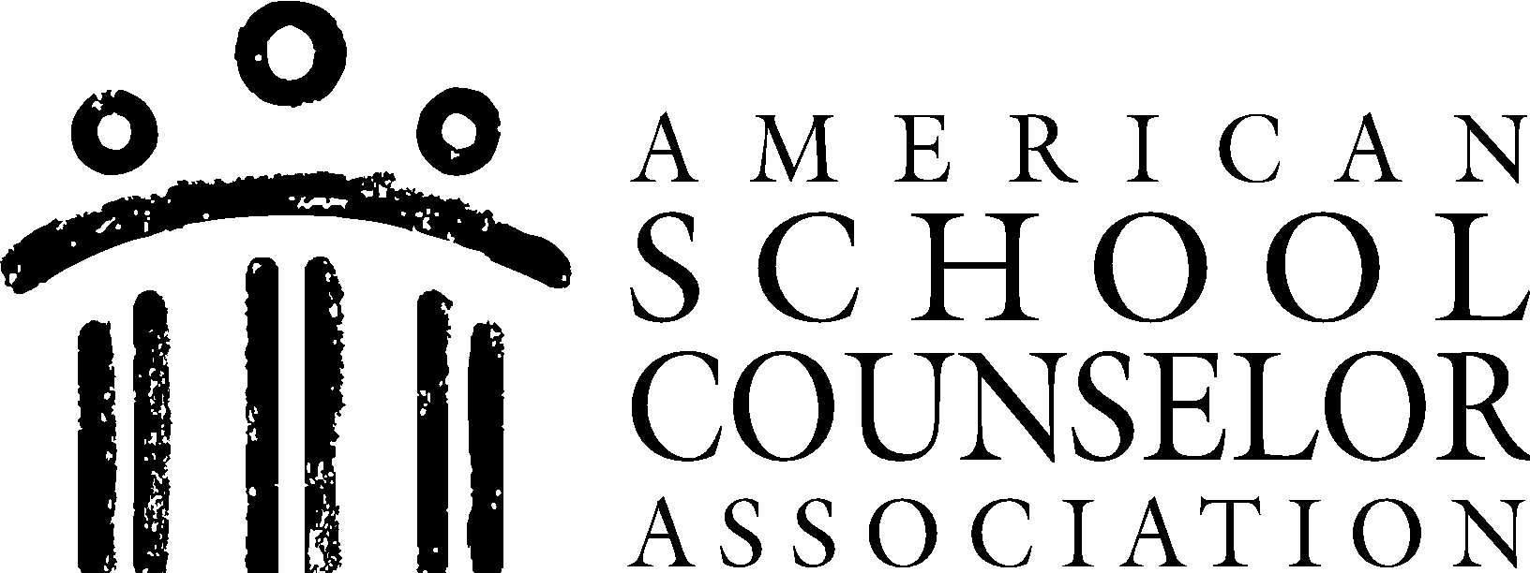 Career Lesson Plan

Presenter: | School Counselor/Career Specialist
Lesson Plan Title: | Strengths Assessment  (Created by: Meredith Brown)

ASCA Student Standards Targeted: |  | Student Learning Objectives:
Identify 1–2 student standards relevant for this targeted group and goal:  (Best practice = select one) |  | For each of the selected student standards, write or select 1–2 learning objectives
M&B# | Mindsets & Behaviors Statement | Student Learning Objectives
1.  2. | Social and Emotional Learning  Academic and Career Development | Student(s) will:  - Demonstrate self-awareness and self-management skills to achieve school and life success.  - Identify and understand their strengths, interests, and values in relation to future academic and career opportunities.

Materials:
Age-appropriate strengths assessment surveys or questionnaires designed for middle schoolers.

Describe how you will:
Introduce Lesson Topic/Focus: | Create an open and transparent discussion by expressing the importance of understanding and celebrating individual strengths. Ask open-ended questions about what makes your students unique or things that you are good at.
Communicate the Lesson Objective: | Review the lesson objectives, define what strengths are in simplest terms and qualities that make us who we are.
Teach Content: | Continue to define what strengths are. Introduce the strengths assessment, whether it's a survey, self-reflection exercise, or another tool. Explain that they will use this to explore and identify their strengths. Share inspirational stories or examples of people who discovered and utilized their strengths, even at a young age.
Practice Content: | Facilitate frequent group discussions, projects, homework assignments to ensure students are aware of things they are good at. Allow for deeper reflection and conversation.
Summarize/Close: | Conclude and summarize the topic of conducting a strengths assessment for this group of students. Express the importance of self-awareness and being able to identify their core strengths.

Career Lesson Plan

School Counselor: | School Counselor/Career Specialist
Lesson Plan Title: | Career Exploration - Career Day  (Created by: Meredith Brown)

ASCA Student Standards Targeted: |  | Student Learning Objectives:
Identify 1–2 student standards relevant for this targeted group and goal:  (Best practice = select one) |  | For each of the selected student standards, write or select 1–2 learning objectives
M&B# | Mindsets & Behaviors Statement | Student Learning Objectives
1.  2. | Academic and Career Development  Major career exploration | Student(s) will:  1.) Acquire the knowledge, attitudes, and interpersonal skills to help them understand and respect self and others.  2.) Understand the relationship between personal qualities, education, training, and the world of work.

Materials:
Optional: Professionals from various fields and create career profiles (information about job responsibilities, educational requirements, salary ranges, and personal qualities or skills needed for success)

Describe how you will:
Introduce Lesson Topic/Focus: | Explain the importance of career exploration at their age. Mention that understanding different careers can help them set goals and make informed decisions about their future.
Teach Content: | Provide an overview of what the career day entails. Mention that they will have the opportunity to interact with professionals from various fields, learn about different careers, and even participate in hands-on activities.
Practice Content: | You can continuously offer career exploration tools such as career workshops, reflection and goal setting, and career panels. Consistently remind students careers will be an ongoing topic as they matriculate through school.
Summarize/Close: | Review the significance of this activity and how this offers middle school students a dynamic and engaging opportunity to enter the world of work. Numerous activities provided offer career exploration, communication skills, and gain hands-on experience in a wide range of fields.

