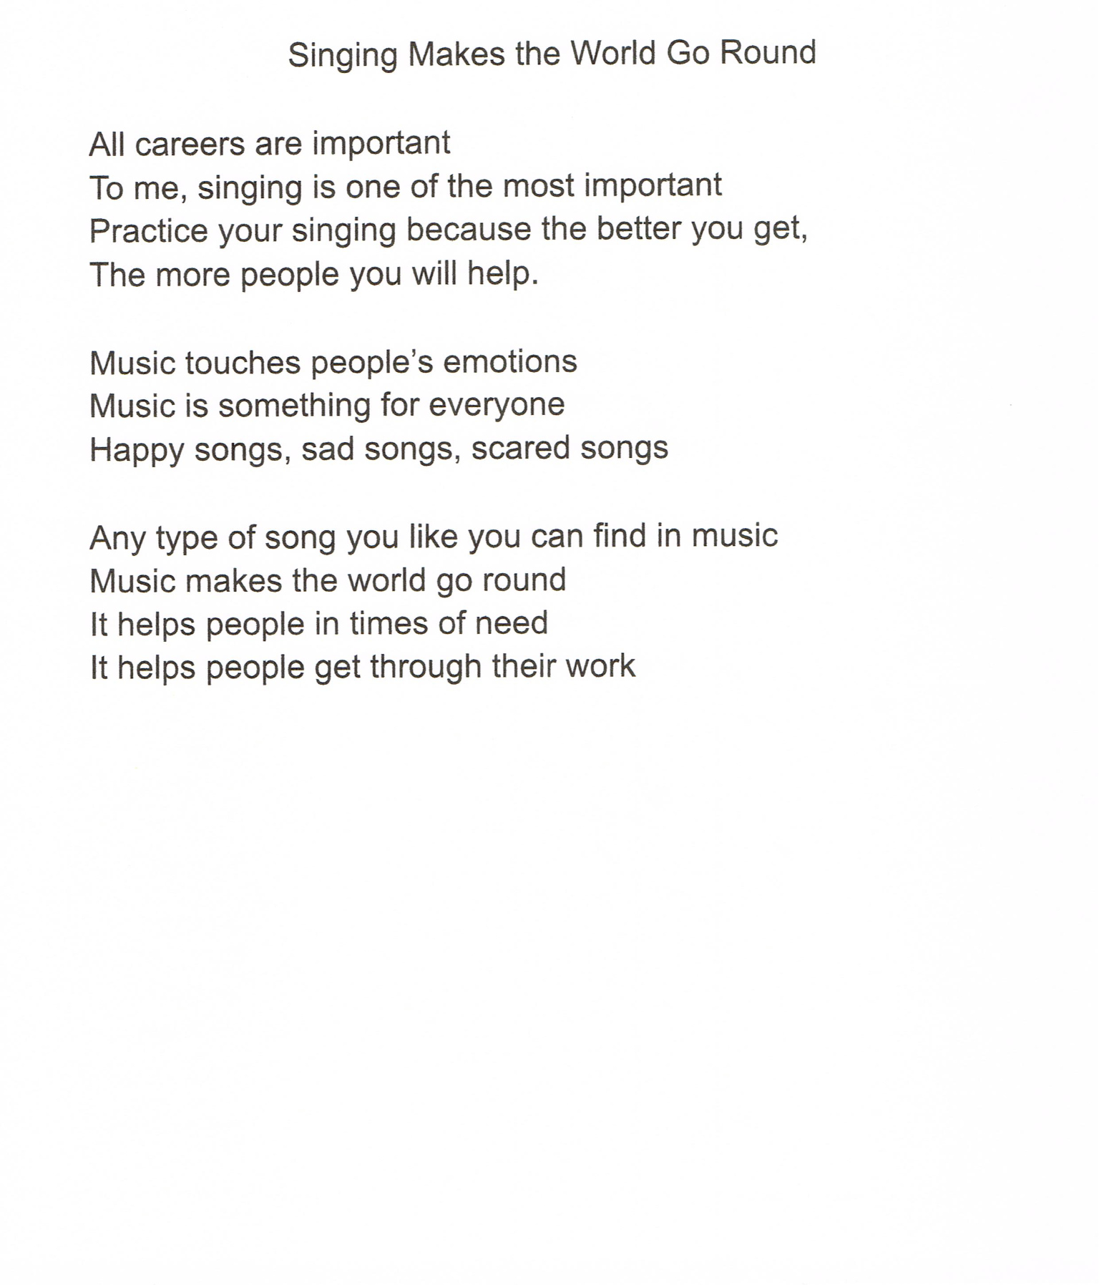
Lily Shufelt Age 8 MHE
G3 Poem
Singing Makes the World Go Round
All careers are important
To me, singing is one of the most important
Practice your singing because the better you get,
The more people you will help.
Music touches people's emotions
Music is something for everyone
Happy songs, sad songs, scared songs
Any type of song you like you can find in music
Music makes the world go round
It helps people in times of need
It helps people get through their work

