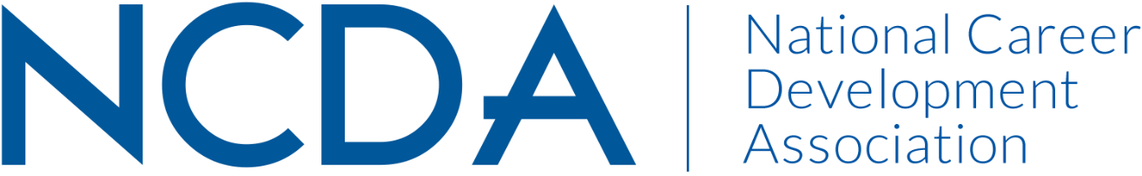

REIMBURSEMENT/CHECK REQUEST

Please submit this form, along with receipts for purchases or invoice for services to the NCDA Treasurer with a copy to the Executive Director dpenn@ncda.org.

Payee:

Address:

City: State: Zip
Phone: E-Mail:

Amount Requested: $

Type: (Check One): Reimbursement Advance

Purpose:

Requested By: Authorized By:

Print Name Print Name

Signature Signature

Date Date

NOTE: Please make a copy for your files. Please allow 3 weeks for processing. If you have questions, contact NCDA at (918) 663-7060.

SUBMIT TO:

For Office Use

Date: _____________

Approved: _

Account #:

Check Sent: _______
NCDA Headquarters
305 N Beech Circle
Broken Arrow, OK 74012
Fax: 918-663-7060
dpenn@ncda.org

