14 de febrero de 2018
CPO-CO-00019-2018

Members
National Association Career Development
Dear collegues:
Receive a cordial greeting from the Board of Directors of the Association of Professional Guidance and the Organizing Committee of the II National Guidance Congress to be held in San Jose, Costa Rica on March 21, 22 and 23, 2018 with the topic " Disciplinary identity and social context in the professional practice of Orientation”. Within the framework of this Congress, the "First Latin American Conference of the National Association for Career Development (NCDA)" will be held.
The purpose of this event is to promote the analysis of the disciplinary identity in the practice of guidence and career counseling from the social context in which it is developed.
We are glad to let you know that Paul Timmins, David M. Reile and Alberto Puertas, outstanding members of NCDA will be joining us.
We take this opportunity to invite more members of NCDA to this Congress and thus have the opportunity to strengthen relationships between colleagues from different latitudes.
On the other hand, Costa Rica is a country with a lot turist places. If you visit us, it will not only be a pleasure to share with you at the congress and the conference but also to give you some advise to enjoy and take advance of your visit. Any help you need in accommodation, hotels and places to go, we are more than willing to help you.
For more information visit us on www.congreso2018.cpocr.org or contact us at the email congresocpo@gmail.com
A cordial greeting from,

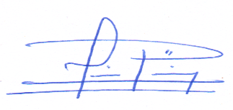

MSc. Luis Emilio Paniagua Calvo | Ana Patricia Ruh Mesén
Board of Directors President  Association of Professional Guidance | Coordinator of the Organizing Committee  II National Guidance Congress

