National Career Development Association
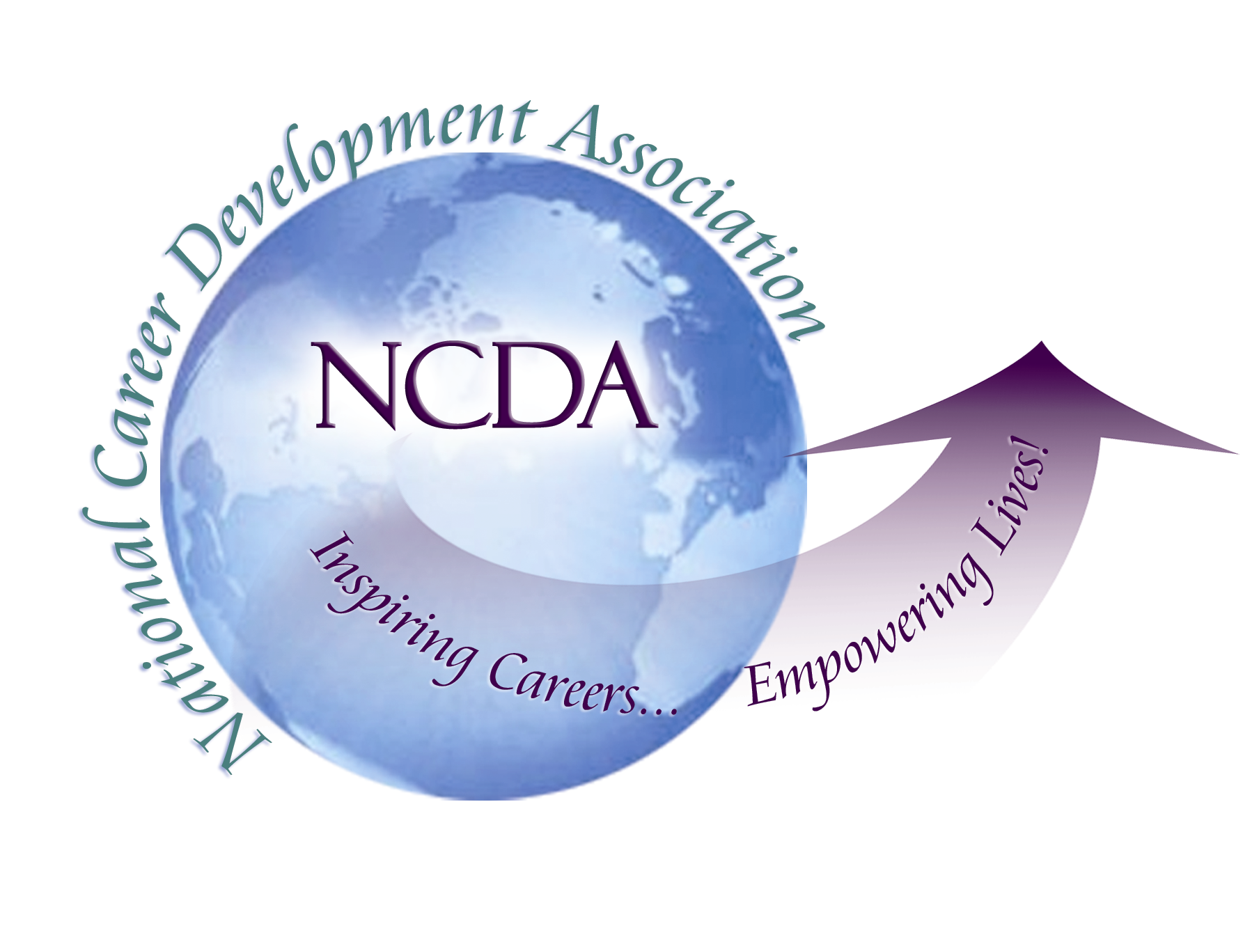
305 N. Beech Circle
Broken Arrow, OK 74012
918/663-7060
Fax: 918/663-7058
www.ncda.org

National Career Development Association
Leadership Academy
Action Learning Project Summary

Participant(s): Alicia Kramer Durham

Board Mentor: Hyung Joon Yoon

Leadership Academy Class: 2017

Project Title: Career Services Credentialing within the Military Community

Project Description: The purpose of this project is to detail the areas where NCDA can market their new credential Certified Career Services Provider (CCSP) within the military community.

Summary/Conclusion:

There are many individuals who provide career and educational services to Service Members, Veterans, and their families who could greatly benefit from the Certified Career Services Provider (CCSP) credential. NCDA can market the credential’s benefits to each Services’ transition team and begin collecting data to apply to have the credential placed on each services Credentialing Opportunities Online (COOL) for Active Duty Career Planners.

Results/Recommendations:

Over the past ten years, the military community has made a considerable effort to provide support and opportunities to ease the career transition from Active Duty. Programs include revamping Transition Education, providing civilian credentialing and apprenticeship opportunities, and hiring staff to provide career and education services. The new vision is to provide career advice throughout an individual’s military life cycle to better prepare them for promotion and/or transition to the civilian workforce. Career Planners are encouraged to move beyond simply referencing how post military career planning can benefits military retention and guide their Service members on multiple career options. Each military service provides professional career and educational guidance during transition and continues to support veterans through the Marine for Life, Soldier for Life, and Airmen for Life Networks. An additional effort provided through the Family Member Employment Assistance Program and My Career Advancement Accounts provides support for spouses to obtain portable credentials, job seeking skills, and resources to find “military spouse” friendly companies.

As a result of these various initiatives, there are over a thousand individuals whose primary duty is to provide career and educational services to Service members and their families. There are also thousands of Reservist and Active Duty Service members who provide career and educational services as a secondary duty (see Table below). Awareness of this infrastructure presents an excellent opportunity for NCDA to market the CCSP credential to these career professionals.
Service/Organization | Civilians who Provide Career Services | Career Planners | Recruiters
Marine Corps | 200 | 425 | 3600
Army | 350 | 900 | 8900
Navy | 260 | 648 | 6200
Air Force | 250 | 648 | 6100
Veterans Affairs | 93 + counselors
Military One Source/  MyCAA/MSEP | contract out for re-bid  10-20
Marine for Life | 7 | 50 (Reservists)
Soldier for Life
Navy for Life
Airmen for Life | 7
TOTAL | 1177 | 2671 | 24800
*All numbers are estimates based on total force numbers from USMC known numbers.

Office of the Undersecretary of Defense for Personnel and Readiness
Transition to Veterans Program Office
This government office designs, oversees, and evaluates all the transition programs per the VOW to Hire Heros Act of 2011. They also establish standards and make recommendations on transition staff’s education and credentials. (www.prhome.defense.gov/Readiness/TVPO/ ) NCDA could attempt to educate the Transition to Veterans Program Office on the importance of staff trained in career advising.

USMC Personal & Professional Development Program
The Marine Corps Personal & Professional Development Program (PPDP) is a blend of Non-Appropriated Funds (NAF) and Government Service (GS) employees that provide educational, career, and transition services. There are several Marine Corps Orders that require the approximately 200 PPDP staff who provide career services to “obtain a professional certification such as Career Counseling or Workforce Development.” The Marine for Life Program vision states that once a Marine always a Marine and continues to provide employment, educational, and networking services to veteran Marines and Sailors attached to Marine Units. The Marine for Life Staff consist of 4 regional representatives, 50 local reserve Representatives, and 2 Social Media managers. Currently, there is a list of Headquarters approved credentials including GCDF, CWDP, Federal Resume, etc. and funding is provided annually for professional development for all PPDP staff. NCDA will need to notify the Personal & Professional Development Headquarters staff of the new credential and request it be added to the list.

Airforce Airmen & Family Readiness
The Airforce Family & Personal Readiness provides several services including career services and transition assistance and consists of GS employees. Although one employee will run a specific program, the employees cross train and rotate specializations from relocation assistance to employment assistance. I recommend NCDA to notify the Air Force’s Headquarters staff of the opportunity and/or market directly to each installation’s directors.

Army Soldier for Life
The Army’s Soldier for Life encompasses the Army’s transition and employment programs. There are Army Readiness Specialists on the installations and in call centers. Currently, the Army contracts companies to provide their programs and services. There are several companies that carry the contracts including but are not limited to; Zieders, Bowen Group, GBX, Booz Allen Hamilton, and Sektor. A recent job announcement does not recommend credentials however require a degree in Human Resources or Psychology and experience in human resources, career counseling or recruiting. I recommend notifying and market the credential to the several contracting companies’ Human Resources department.

Navy Family Readiness
Under the Navy’s Family Readiness are two career service programs; spouse employment services and transition assistance. Like the Army, their specialists are contract employees. I recommend notifying and market the credential to the several contracting companies Human Resources department.

US Coast Guard Force Education & Professional Development Branch
The US Coast Guard has a handful of Education Officers who assist Coasties with career plans. NCDA should notify and market to the FORECOM Training Division Chief.

Veteran’s Affairs
In addition to vocational rehabilitation counselors, the VA has several employment coordinators all who assist veterans in finding their new careers. NCDA will need to market to the VA Department of Vocational Rehabilitation & Employment (VR&E).

Military One Source/MyCAA
My Career Advancement Account is a scholarship for military spouse of $ 4000 per year for two years to obtain licenses, certificates, and associates degrees for a portable career. To receive the scholarship spouses are required to develop a career plan with the guidance of a career counselor. Currently, these career counselors are employees of Zieders and work in a call center in Woodbridge, VA. I recommend NCDA market to Zieders (or the next contract winner) the benefits of the CCSP.

Activity Duty Career Planners and Recruiters
Credentialing Opportunities Online (COOL) provides federal COOL dollars for Service members to obtain certifications and licenses related to their Military Occupation or MOS. The COOL program encourages professionalization of the Service member’s job and ensures Service members are professional prepared for civilian workforce. Visit the websites below to explore each Branch’s COOL websites.
Army COOL – https://www.cool.army.mil
Department of Navy COOL– https://www.cool.navy.mil
Navy COOL – https://www.cool.navy.mil/usn
Marine Corps COOL – https://www.cool.navy.mil/usmc
Air Force COOL - https://afvec.langley.af.mil/afvec/Public/COOL/Default.aspx

GCDF was a recognized credential for Career Planners and Recruiters and COOL dollars were paying the fee to CCE for the GCDF credential. Recently, many certificates have been removed including GCDF due to the congressional mandate for COOL to ensure quality of credentials. The COOL Inclusion Guidelines
(http://www.cool.navy.mil/usmc/agency_documents/COOLCredentialInclusionGuidelines.pdf) encourages agencies to attain accreditation of their certification program; however they do offer an application with checklist to request inclusion on COOL websites. This provides a unique opportunity for NCDA to be one of the few certificates listed for Career Planners. I recommend NCDA completes the application to place CCSP on COOL sites. The major barrier to immediate approval will be the lack of data from the assessment; therefore NCDA may want to wait to complete the COOL applications until they have adequate data to demonstrate confidence in their assessment.

The COOL application includes a standards checklist for the credential. The Yes/No questions include:
- The credentialing body (CB) will not require the candidate to have completed training that is solely provided by the CB.
- If the CB does provide an educational or training program, it must not imply that it is the only approved program as a requirement for the credential.
- If the CB does provide an educational or training program, those individuals responsible for training must not be affiliated with or responsible for the development of credentialing standards or the approval process.
- The credential exam fee must not be bundled with non-examination-related costs (i.e. training materials, membership cards, organizational magazines, etc...).
- The CB must document the specific tasks, knowledge, job duties, and / or skills that are purportedly being measured by the assessment process (e.g. exam, portfolio review, requirements review) associated with exam.
- The CB must document the development of the exam or assessment, specifying psychometric processes.
- The content areas of the assessment or exam must be directly aligned to information gathered during a job/task analysis, role delineation, and / or subject-matter expert consultation.
- Evidence regarding the validity and reliability of the assessment / exam scores must be documented.
- The CB must publish all assessment / examination processes and procedures required of the candidate.
- The certification/license must be recognized and in use by industry/organizations other than the CB's organization.
- The CB must be accessible and responsive to both applicant and certification holder (i.e. Internet, Phone, Email).
- Membership in an association affiliated with the CB will not be required for initial certification/license.
- The certification/license must have a time limit or Continuing Education requirements, with options for recertification and/or maintenance clearly outlined.
- The credential(s) offered must not be tailored towards or centric to military service members or occupations. It must fulfill a need in the civilian workforce.

Appendix # 1 Communication with Credentialing Board

From: Dr. Connie Pritchard [mailto:doctor@pritchardgroup.com]
Sent: Tuesday, March 28, 2017 9:33 AM
To: Durham CIV Alicia K; Hyung Joon Yoon; doctor@pritchardgroup.com
Subject: LA project responses

Hi, Alicia, thank you for the update.
We are on our way to being listed on DOL's credential site (careeronestop.org). We have been in contact with the head individual and received preliminary approval from careeronstop.org. The actual credentials will be listed there when they go live (July 2017).
I am not sure if you are considering all 5 credentials or only the CCSP. I am answering from the perspective of all credentials.
The areas you list where we are not compliant are similar to those requirements were our credentials to become recognized by NCCA. We cannot apply for NCCA Accreditation until we have been in business for at least 2 years; however, we are trying to design the credentials so that we can move in that direction at some point, if we wish to do so.
In some credentials, there are already multiple paths to the credential as described on the website (http://www.ncda.org/aws/NCDA/pt/sp/credentials). We have added a considerable amount of information there in the last weeks. Off the top of my head (without examining in detail), I think all of the credentials currently have more than 1 way to gain the credential other than going through an NCDA program.
Remember that the credentials are through an affiliate organization of NCDA as well (the NCC), thus no training is provided by the credentialing board (NCC). So technically we are compliant.
We are currently in the pilot phase of launching our credentials and beginning to gather data for #6, 7 and 8. We plan to continue collecting data and have set up assessment portions of the credentials to allow us to do exactly that. I suspect it will be well into fall before we can crunch data.
things are a ramping up for us at the moment as we are beginning our pilots and fielding lots of questions while testing software and our assessments. Great learning for us but a bit crazy!
Good luck with your project! I think I have addressed all your questions. It appears that we are in good shape.
cjp

