National Career Development Association
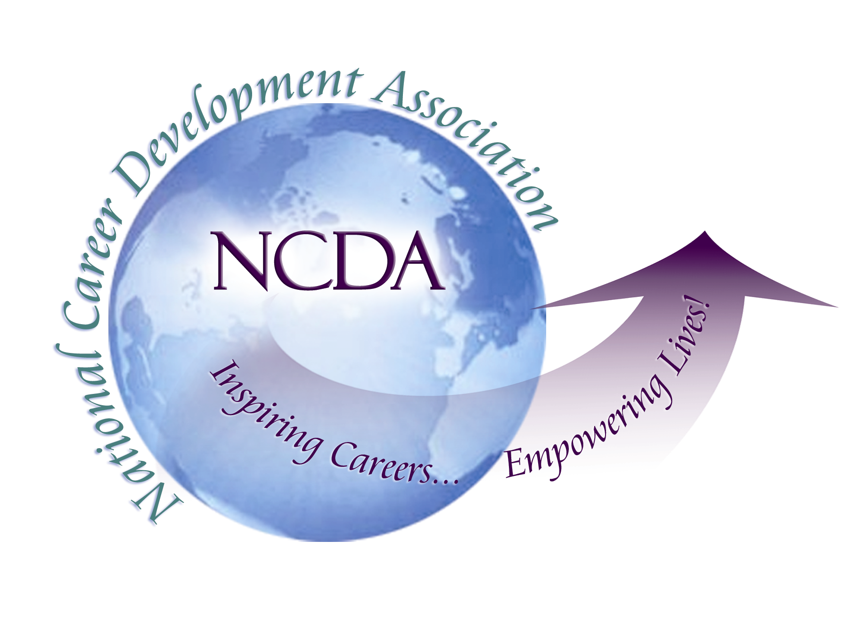
305 N. Beech Circle
Broken Arrow, OK 74012
918/663-7060
Fax: 918/663-7058
www.ncda.org

National Career Development Association
Leadership Academy
Action Learning Project Summary

Participant(s): Linda Sollars

Board Mentor: Rich Feller

Leadership Academy Class: Class of 2016

Project Title: CAREERtalks

Project Description: This study is designed to develop and test a presentation format, similar to TEDtalks, that can be used at future conferences in addition to existing presentation formats. This format is tentatively called CAREERtalks and includes 3 separate 17 minute talks in 1 hour with a short Q&A at the conclusion of each talk. Each talk will focus on one specific topic in career development and the 3 talks can focus on one area or each can be unique. This format was tested at the Colorado Career Development Fall Conference and post-presentation surveys were collected. This proposal will provide the results, the format and questions used in presentation.

Summary/Conclusion: The CAREERtalks format was well-received by the Colorado Career Development Association attendees in the Fall, 2014. Nine potential presentations were submitted and the board members selected the final 3 presentations on diverse topics. Each presenter received a format document providing information on creating this presentation, including structure, writing the script, timing and creating slides. The presentations were recorded and posted on YouTube with links to the CCDA website.

Results/Recommendations: Post-presentation surveys were extremely positive and several requests have been received asking to present a CAREERtalk at the CCDA Fall 2015 Conference. Requests were made to have this at the NCDA conference, as well. This format will enhance the variety of information presented at the conferences and will attract presenters who want to provide a more concise informational session. Additionally, NCDA can accommodate a wider variety of topics and presenters. The recommendation is to launch this presentation style at the 2016 NCDA National Convention, taking the place of 2-3 hours of round tables or one keynote speaker. This presentation style needs to be included in the request for presentations sent out by NCDA in the fall. Professionally film each talk and post to the NCDA website. Having 2 microphones in the audience to field questions.

